TopKPI2 Architecture

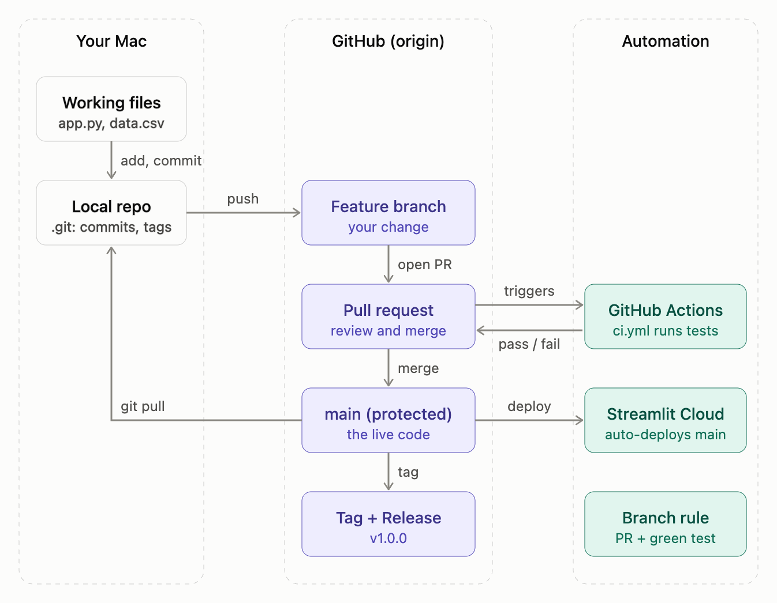
Diagram 1 is the life of one change.
- You edit working files on your Mac.
- git add and git commit save a snapshot into the local repo (the hidden .git folder).
- git push sends it to a feature branch on GitHub.
- You open a pull request, which triggers GitHub Actions. ci.yml compiles app.py and runs the smoke test, then reports pass or fail back to the PR.
- The branch rule only allows the merge once the test is green. The merge lands in main, the live code.
- Streamlit Cloud redeploys from main. This is my assumption, because I haven't seen your hosting setup. If you host elsewhere, that box is where it differs.
- Tags and releases (v1.0.0) mark chosen commits on main.
- git pull brings the new main back to your Mac, which closes the loop.
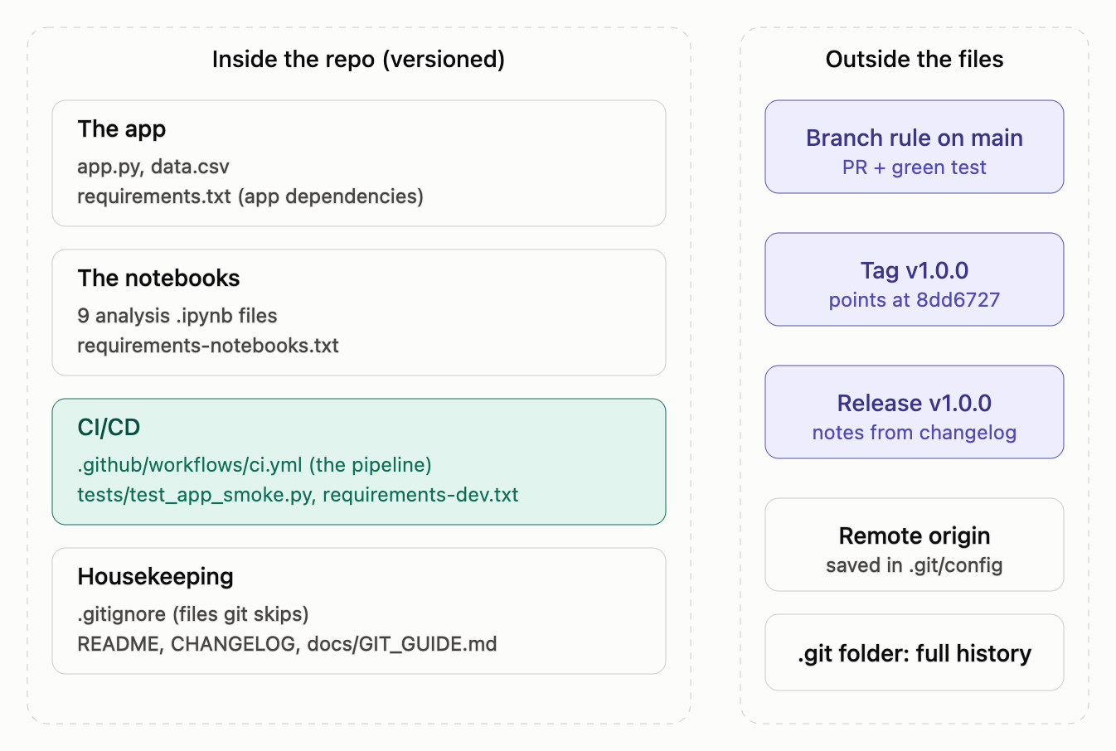
Diagram 2 is where each file and setting lives.
- Files in the repo are versioned. That covers the app, the notebooks, the CI/CD files and the housekeeping files (.gitignore, README, changelog, guide).
- Settings outside the files are the branch rule, tag and release on GitHub, plus the remote URL and full history inside .git. You change those in GitHub's UI or with git commands, not by editing a project file.
Local versus remote: your Mac and GitHub each hold a full copy of the history. Nothing reaches GitHub until you push, and nothing reaches your Mac until you pull.

